Assignment - 4

**Ultrasonic sensor simulation**

**In Wokwi**

|  |  |
| --- | --- |
| ASSIGNMENT DATE | 24 OCTOBER 2022 |
| TEAM ID | PNT2022TMID03711 |
| PROJECT NAME | SMART SOLUTIONS FOR RAILWAYS |
| MAXIMUM MARKS | 2 MARKS |

**Code:**

**#include <WiFi.h>**

**#include <PubSubClient.h>**

**void callback(char* subscribetopic, byte* payload, unsigned int**

**payloadLength);**

**//-------credentials of IBM Accounts------**

**#define ORG "ytluse"**

**#define DEVICE_TYPE "2702"**

**#define DEVICE_ID "12345"**

**#define TOKEN "O+n)Eh+lNX0y3?rG!8" /**

**String data3;**

**char server[] = ORG ".messaging.internetofthings.ibmcloud.com";**

**char publishTopic[] = "iot-2/evt/Data/fmt/json";**

**char subscribetopic[] = "iot-2/cmd/test/fmt/String";**

**char authMethod[] = "use-token-auth";**

**char token[] = TOKEN;**

**char clientId[] = "d:" ORG ":" DEVICE_TYPE ":" DEVICE_ID;**

**WiFiClient wifiClient;**

**PubSubClient client(server, 1883, callback ,wifiClient);**

**const int trigPin = 5;**

**const int echoPin = 18;**

**#define SOUND_SPEED 0.034**

**long duration;**

**float distance;**

**void setup() {**

**Serial.begin(115200);**

**pinMode(trigPin, OUTPUT);**

**pinMode(echoPin, INPUT);**

**wificonnect();**

**mqttconnect();**

**}**

**void loop()**

**{**

**digitalWrite(trigPin, LOW);**

**delayMicroseconds(2);**

**digitalWrite(trigPin, HIGH);**

**delayMicroseconds(10);**

**digitalWrite(trigPin, LOW);**

**duration = pulseIn(echoPin, HIGH);**

**distance = duration * SOUND_SPEED/2;**

**Serial.print("Distance (cm): ");**

**Serial.println(distance);**

**if(distance<100)**

**{**

**Serial.println("ALERT!!");**

**delay(1000);**

**PublishData(distance);**

**delay(1000);**

**if (!client.loop()) {**

**mqttconnect();**

**}**

**}**

**delay(1000);**

**}**

**void PublishData(float dist) {**

**mqttconnect();**

**String payload = "{\"Distance\":";**

**payload += dist;**

**payload += ",\"ALERT!!\":""\"Distance less than 100cms\"";**

**payload += "}";**

**Serial.print("Sending payload: ");**

**Serial.println(payload);**

**if (client.publish(publishTopic, (char*) payload.c_str())) {**

**Serial.println("Publish ok");**

**} else {**

**Serial.println("Publish failed");**

**}**

**}**

**void mqttconnect() {**

**if (!client.connected()) {**

**Serial.print("Reconnecting client to ");**

**Serial.println(server);**

**while (!!!client.connect(clientId, authMethod, token)) {**

**Serial.print(".");**

**delay(500);**

**}**

**initManagedDevice();**

**Serial.println();**

**}**

**}**

**void wificonnect()**

**{**

**Serial.println();**

**Serial.print("Connecting to ");**

**WiFi.begin("Wokwi-GUEST", "", 6);**

**while (WiFi.status() != WL_CONNECTED) {**

**delay(500);**

**Serial.print(".");**

**}**

**Serial.println("");**

**Serial.println("WiFi connected");**

**Serial.println("IP address: ");**

**Serial.println(WiFi.localIP());**

**}**

**void initManagedDevice() {**

**if (client.subscribe(subscribetopic)) {**

**Serial.println((subscribetopic));**

**Serial.println("subscribe to cmd OK");**

**} else {**

**Serial.println("subscribe to cmd FAILED");**

**}**

**}**

**void callback(char* subscribetopic, byte* payload, unsigned int payloadLength)**

**{**

**Serial.print("callback invoked for topic: ");**

**Serial.println(subscribetopic);**

**for (int i = 0; i < payloadLength; i++) {**

**//Serial.print((char)payload[i]);**

**data3 += (char)payload[i];**

**}**

**Serial.println("data: "+ data3);**

**data3="";**

**}**

**Diagram.json:**

**{**

**"version": 1,**

**"author": "SHAJIVAN S",**

**"editor": "wokwi",**

**"parts": [**

**{"type": "wokwi-esp32-devkit-v1", "id": "esp", "top": 6, "left": -66, "attrs": {} },**

**{"type": "wokwi-hc-sr04", "id": "ultrasonic1", "top": 32.56, "left": 81.02, "attrs": {} }**

**],**

**"connections": [**

**["esp:TX0", "$serialMonitor:RX", "", [] ],**

**["esp:RX0", "$serialMonitor:TX", "", [] ],**

**["esp:VIN", "ultrasonic1:VCC", "red", [ "h-31.67", "v-176.8", "h152", "v163.33" ] ],**

**["esp:D18", "ultrasonic1:ECHO", "green", [ "h11.37", "v64.67", "h121.33" ] ],**

**["esp:D5", "ultrasonic1:TRIG", "green", [ "h16.7", "v45.07", "h4" ] ],**

**["esp:GND.1", "ultrasonic1:GND", "black", [ "h8.7", "v14.7", "h138.67" ] ]**

**]**

**}**

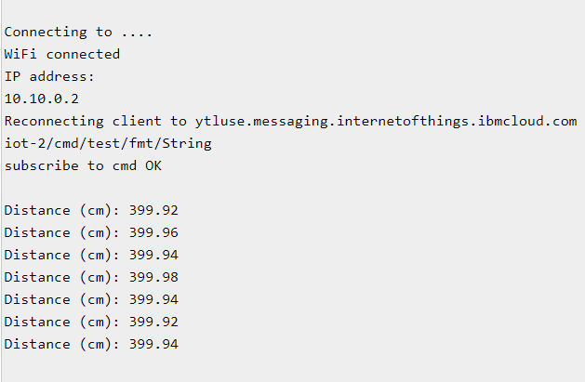**OUTPUT:**

**Circuit Diagram:**

